**Keyword Group:** Tutorial & Guides

**Keyword:** PHP Auth

**Audience:** Secure Code Specialist, DevOps Manager, Database Security Analyst, Frontend Security Engineer, API Integration Specialist, Mobile App Developer, Web Application Developer

**Avg. monthly searches:** 110

**Format:** Resource Guide

**A Comprehensive Resource Guide with Sample Codes for Secure PHP Auth**

***Securing Your PHP Application with Cutting-Edge Auth Techniques in you PHP Boilerplate***

Hey there, fellow developers! Let us talk about something we all know is super important but can be a real headache - keeping our PHP apps secure.

You know how it goes – you are working on this cool new project, everything is coming together nicely, and then you remember... security. Ugh. But here is the thing, In today's world, we cannot afford to treat security as an afterthought. It is like leaving your front door wide open and hoping nobody walks in, right?

So, let us chat about PHP authentication. It is basically how we make sure that the people using our apps are who they say they are, and that they only get to see and do what they are supposed to. Whether you are building a PHP application or using a custom PHP boilerplate, getting this part right is essential. Implementing a strong **PHP Auth** system ensures that your application remains secure, user-friendly, and compliant with industry standards.

In this article, we are going to break down important stuff about PHP auth. We will cover the basics, then dive into the process of setting up authentication in PHP, covering advanced techniques like **PHP OAuth, PHP cookie authentication**, and **PHP token-based authentication**, and cover essential security practices like **PHP password hashing**, **PHP SQL injection prevention**, and **PHP XSS prevention**. By the end of this guide, you will have a solid understanding of how to implement secure authentication in your PHP boilerplate and ensure your application follows **PHP security best practices**.

**Understanding PHP Auth in Your PHP Boilerplate and Setting Up Authentication in Your PHP Boilerplate**

**PHP Auth** is the cornerstone of securing user data and controlling access within your application. A well-implemented authentication system allows you to verify the identity of users and grant or deny access based on their credentials.

When working with a PHP boilerplate, integrating a solid authentication mechanism not only saves time but also ensures that your application is built on a secure foundation.

To get started with PHP Auth, you will need to implement a basic user authentication system. This typically involves user registration, login, and session management. Below is a simple example of setting up user authentication in PHP using sessions.

**Enhancing Securing with PHP Password Hashing**

**PHP password hashing** is crucial for storing user passwords securely. Instead of storing plain-text passwords, you should hash them using functions like ***`password_hash()`***and verify them with ***`password_verify()`.*** This method ensures that even if your database is compromised, attackers will not easily retrieve user passwords.

**Implementing PHP OAuth for Secure Third-Party Authentication**

**PHP OAuth** is a widely used protocol that allows users to authenticate using their existing accounts from third-party services like Google, Facebook, or Twitter. Integrating OAuth into your PHP boilerplate can simplify the user experience by enabling social logins while maintaining security. Below is an example of setting up OAuth using the PHP League’s OAuth2 Client library.

This setup allows users to log in using their Google accounts, securely handling authentication tokens and user data.

**Securing Sessions with PHP Cookie Authentication**

**PHP cookie authentication** is a method where user credentials are stored in cookies for subsequent requests. This is particularly useful for "Remember Me" functionality, allowing users to stay logged in even after closing the browser. To implement cookie-based authentication in your PHP boilerplate

Always ensure that cookies are sent over secure HTTPS connections and are marked as HttpOnly and Secure to protect against attacks like session hijacking and cross-site scripting (XSS).

**Implementing PHP Token-Based Authentication**

**PHP token-based authentication** is another secure method for managing user sessions. Tokens are generated when a user logs in and are used to authenticate subsequent requests. This approach is commonly used in APIs and single-page applications where session management needs to be stateless.

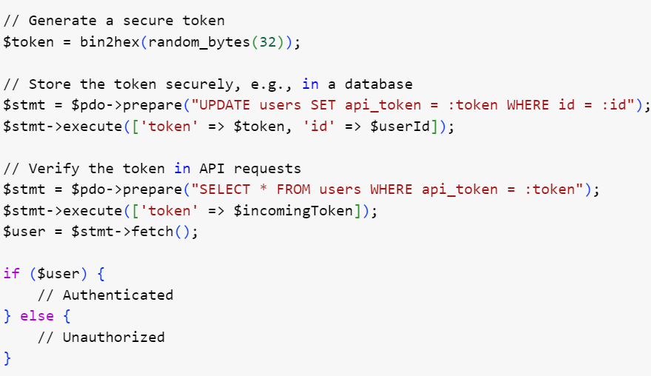

Tokens should be securely generated and stored, ensuring that they cannot be easily guessed or forged.

**PHP SQL Injection Prevention using prepared statements**

**PHP SQL injection prevention** is critical when handling database queries. Always use prepared statements or ORM (Object-Relational Mapping) frameworks to protect your queries from malicious input.

Prepared statements automatically escape user inputs, making SQL injection attacks much harder to execute.

**PHP XSS Prevention- Sanitizing user Inputs**

**PHP XSS prevention** is essential to protect your application from cross-site scripting attacks. Always sanitize and escape user inputs, especially when rendering them in HTML.

This practice prevents attackers from injecting malicious scripts into your web pages, which could be executed by other users

**PHP Security Best Practices**

Finally, adhering to **PHP security best practices** is fundamental for maintaining the overall security of your application. This includes:

* Regularly updating your PHP version and libraries to benefit from the latest security patches and protect against known vulnerabilities.
* Using HTTPS to encrypt data transmitted between the client and server.
* Control user permissions and access to different parts of your application
* Implementing proper error handling to avoid exposing sensitive information.
* Validating and sanitizing all user inputs to prevent injection attacks.
* Using security headers like Content-Security-Policy to mitigate XSS attacks.

Implementing a secure **PHP Auth** system is essential for any PHP application. Stay current with the latest security practices, and regularly evaluate and update your user authorization methods to ensure your PHP boilerplate and its users remain secure against emerging threats. By implementing strong user authorization mechanisms, you will enhance the overall security of your PHP boilerplate, providing peace of mind for both you and your users